Lightweight Seal Plates and Quick Connect Snoots for Fast Delay Lines at the Navy Precision Optical Interferometer

Preliminary Proposal

Dustin John Haines
Bradley Ian Kingsley
Trung Son Nguyen

2022-2023
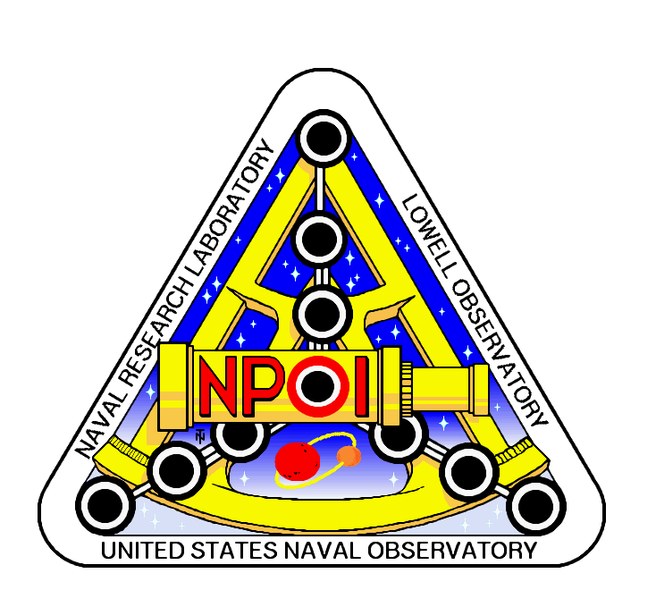

Project Sponsor: Jim Clark, Director, and Chief Engineer
Instructor: Armin Eilaghi

DISCLAIMER
This report was prepared by students as part of a university course requirement. While considerable effort has been put into the project, it is not the work of licensed engineers and has not undergone the extensive verification that is common in the profession. The information, data, conclusions, and content of this report should not be relied on or utilized without thorough, independent testing and verification. University faculty members may have been associated with this project as advisors, sponsors, or course instructors, but as such they are not responsible for the accuracy of results or conclusions.

TABLE OF CONTENTS

Contents
DISCLAIMER 1
TABLE OF CONTENTS 4
1 BACKGROUND 5
1.1 Introduction 6
1.2 Project Description 6
1.3 Original System 8
1.3.1 Original System Structure 8
1.3.2 Original System Operation 9
1.3.3 Original System Performance 9
1.3.4 Original System Deficiencies 10
2 REQUIREMENTS 10
2.1 Customer Requirements (CRs) 11
2.2 Engineering Requirements (ERs) 11
2.3 House of Quality (HoQ) 12
3 DESIGN SPACE RESEARCH 13
3.1 Literature Review 14
3.1.1 Student 1 (Bradley Ian Kingsley) 14
3.1.2 Student 2 (Dustin John Haines) 15
3.2 Benchmarking 16
3.2.1 System Level Benchmarking 16
3.2.2 Subsystem Level Benchmarking 18
3.2.3 Subsystem #3: Snoots and Snoot Fixture/Adjuster 21
3.3 Functional Decomposition 22
3.3.1 Black Box Model 22
3.3.2 Functional Model/Work-Process Diagram/Hierarchical Task Analysis 23
4 CONCEPT GENERATION 24
4.1 Full System Concepts 25
4.1.1 Full System Design #1: Magnesium, Rubber Sleeve Seal, Acrylic Sight Port. (M.R.A.) 25
4.1.2 Full System Design #2: Aluminum, O-Ring Seal, Polycarbonate Sight Port. (A.O.P.) 25
4.1.3 Full System Design #3: Steel, Hose Sleeve Seal, Tempered Glass. (S.H.T.) 25
4.2 Subsystem Concepts 25
4.2.1 Subsystem #1: Front Seal Plate 25
4.2.2 Subsystem #2: Sight Port 26
4.2.3 Subsystem #3: Snoots and Snoot Fixture/Adjuster 27
5 DESIGNS SELECTED – First Semester 29
5.1 Technical Selection Criteria 30
5.2 Rationale for Design Selection 30
6 REFERENCES 31

BACKGROUND

Introduction
The Navy Precision Optical Interferometer (NPOI) is a large astronomical observation station, created by the Navy Research Lab. The goal of NPOI is to observe faint, double, and triple stars, using the siderostat stations and use of the delay and combining lab. The 2022-2023 NPOI capstone will be based on the Fast Delay Lines (FDL), specifically the seal plates and snoots. The project includes designing rear seal plates, front seal plates with snoots, a snoot adjustment fixture, and a snoot split design. The team will design a simple rear seal plate to hold the moderate FDL vacuum, as well as integrate sight ports in the seal plate for easy inspection. The front seal plate will seal vacuum, hold the stellar and metrology snoots, and integrate view ports for easy inspection. The seal plates will also need to have a weight of 35 lbs. or less. The snoots must have an inner room fixture, allowing adjustment (pitch and yaw), as well as holding the last section of the snoot split design. The inner room section of the snoot will be stationary when accessing the front of the FDL’s. The split snoot design is a sectional tube which will be easily able to have sections removed for access in removing the front seal plate. The combination of these four objectives is to create a FDL seal plate system which one technician can assemble and disassemble with ease.
The sponsor of this project Jim Clark is interested in completing this design project because of maintenance requirements of the FDL’s, along with the need for keeping the interferometer on sky nightly. The maintenance requirements for the FDL’s are ribbon cable replacement, voice coil tuning, piezo tuning, bearing replacement, and leaf spring replacement. These maintenance items must be repaired in a quick and efficient time frame, allowing the seal plates to be less than 35 lbs., allowing any single technician the option to vent and disassemble an FDL individually. As well as removing the use of the gantry crane completely. This allows the small staff at NPOI to work on issues in parallel, instead of one at a time. Removing the gantry crane from the FDL room will also remedy the issue of tripping hazards within the FDL room, due to the gantry crane tracks. The use of the sectional snoot allows for ease of disassembly of the snoots and removes a lengthy step once fully reassembled. Alignment of the snoots will be removed using sectional snoots, this allows for the inner room section of snoot to be fixed, allowing the team to keep alignments of snoots through disassembly and reassembly. The remedy of these issues will allow the client and stakeholders to more easily maintain the FDL’s, remove safety issues in the FDL room, and reduce the number of needed alignments during FDL maintenance.

Project Description
The following is the project description given by the Navy Precision Optical Interferometer and client Jim Clark.
The central goal of all astronomical observation is to better understand our universe and how it works. Earth and our solar system are just one possible astrophysical arrangement, so what we can learn by looking around our own neighborhood is limited. By observing the billions of other systems out there, we can develop a better understanding of what other arrangements are possible, how they might have formed, and what the implications are for potential future off-earth explorations.

Just as when you view the world with just one eye, there are limitations to viewing celestial phenomena from a single point, i.e., a traditional telescope. Observation of many 2D features benefit from combining multiple views of the target from points that are spread out spatially, a technique called interferometry. For example, the centroid of binary systems changes as one star orbits its partner, and it is the centroid of the binary system that a single telescope measures to generate a catalog of stellar positions; other applications include star-spots (which have yet to be seen!), accretion discs (as the stars spin and toss out matter of different temperature and mass), star rotations (what is the spin rate and orientation of polar axis?) and other interesting science that single telescopes simply cannot measure; we may eventually be able to use nulling interferometry for exoplanet detection.

The Navy Precision Optical Interferometer (NPOI), an astronomical long-baseline optical interferometer, has been in operation on Anderson Mesa, just outside Flagstaff, Arizona, since 1994. This facility was funded by the Naval Research Lab and the U.S. Naval Observatory and built on Forest Service land supplied using a Special Use Permit (SUP), held by Lowell Observatory. An aerial view of the site, shown in Figure 1, illustrates the general shape and layout of the 2.2-meter to 437-meter baseline array. The NPOI has a unique capacity for detecting and determining motions and orbits of binary systems. Many regional partners collaborate with NPOI to take advantage of its unique capabilities, including Northern Arizona University, New Mexico Tech, Seabrook Engineering, Tennessee State University, and Lowell Observatory.

The NPOI collects and combines light from up to six apertures simultaneously to form a high spatial resolution synthetic aperture. The wavelength range of operation is currently in the visible spectrum, 400 nanometers to 800 nanometers, and will soon include infrared wavelengths. Reconfigurability of the array generates baselines from 2.2-meters to 437-meters, and the light collected at each station is transported as a 12.7 centimeters beam through evacuated pipes to a beam combiner. Reconfiguration of the array is analogous to a zoom lens on a Digital Single-Lens Reflex (DSLR) camera.

Many components require maintenance or repair, especially the heart of NPOI, the Fast Delay Lines (FDL). The Fast Delay Lines (Figure 2), housed by vacuum tanks are used to zero the path difference, within 10’s of nanometers, from each siderostat to allow for the beams to be combined in phase. At the front of these tanks, snoots (Figure 4) are used to equalize air distances through the entire optical path. Snoots allow stellar light into the FDL’s and back out after respective reflections. The Snoots contain custom vacuum windows allowing stellar light to enter and exit of the FDL tanks. The FDL tank Seal Plates also allow the metrology beam into and out of the tank which allows for highly accurate measurements of cart positions, on the order of a nanometer. These inner tank components from time to time must be repaired. This entails the front and/or rear seal plates to be moved/stowed and FDL tank inners worked on in an appropriate clean environment. Then all components must be reinstalled easily. Presently, an overhead gantry crane and multiple technicians are required for disassembly of the FDL seal plates and snoots.

Over the course of Fast Delay Line (FDL) use, there is need for periodic maintenance within the vacuum tanks confining the FDL Carts. On the front of the FDL’s there are seal plates which capture snoots to relay the light in and out of the inner room. Figure 3 shows the snoots exiting the delay line tanks. Figure 4 shows the snoots as seen from the inner room. These seal plates and snoots use many features which take long lengths of time to disassemble and assemble. This issue is apparent on the front and rear of the tanks, although the rear seal plates do not have optical pass throughs. Reducing the use of large tools (gantry crane) and quantity of technicians needed to complete this task would be most beneficial to the Opto-Mechanical Group (OMG) at NPOI.

Original System
The original Fast Delay Line seal plates, snoot design, and snoot fixture is a currently used mechanical assembly which is shown in figures 1, 3 and 4. This system has been in place since 1994, sealing vacuums and allowing the FDL carts to properly do their job. The NPOI opto-mechanical group (OMG) have gently pushed for an updated system which removes all safety issues and reduces time for regular or needed maintenance.

Original System Structure
The original structure of the FDL and snoot system have been unchanged since 1994. The original snoot system design was comprised of copper pipes, cut to various lengths to correct for air path difference, extruding through a foam wall. The window flange was silver soldiered, and a T was silver soldiered to allow a vacuum pump bellow connection. These snoots connect to the seal plates via a custom flange which held FDL snoot stubs and metrology windows. The connection was made via a larger OD hose, and c-clamps. There are only snoots (extruding vacuum pipes) for the stellar light, metrology light enters/exits the seal plate via a small vacuum window. These stellar snoots are held and aligned via a saddle mount, adjustment made by adjusting nuts on all thread, or shims between the fixture and snoot copper. This style snoot design must be fully removed to access the front of the FDL and must be realigned after each removal. A cardboard tube with bubble foil surrounds the snoots and metrology beam between the inner room wall and front seal plate, this restricts all light from entering and obstructing the beams, shown in figure 1. The fast delay line seal plates are 22” diameter, 2” thick, aluminum plates, machined specifically to o-ring dimensions and snoot placement. These seal plates are full weight, only needed material removal was completed for the needed features, no pocketing for light weighting was completed. These full weight plates require the use of a tracked gantry crane, within the FDL room. The Opto-Mechanical Group (OMG) has maintained these tanks many times each year, taking multiple hours per tank.

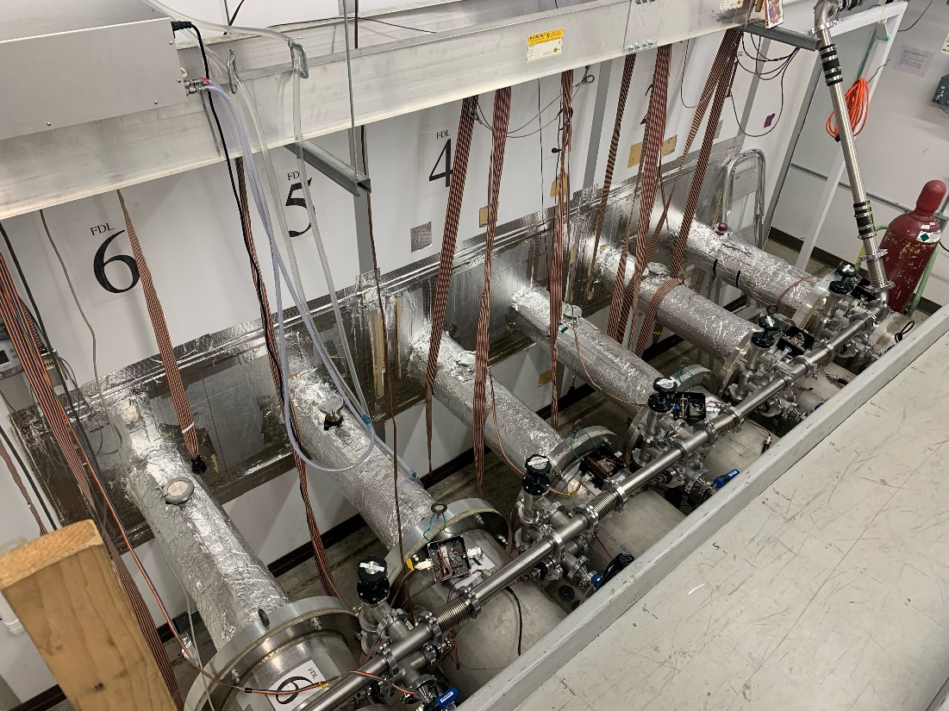
Fig. 1 - Snoots, Front Seal Plate, Inner Room Wall, and Snoot Light Covers

Original System Operation
The original system operation was very static, other than when maintenance is needed. When the interferometer is in use, observing, the snoots, metrology windows, seal plates, and snoot fixture all have specific jobs to fulfill. During observation the snoots are allowing light in and out of the FDL tanks from within the inner room. The difference in length (FDL 6 is shortest, FDL 1 is longest) allows for air path difference to be equalized. When the FDL’s are maintained, these snoots must be fully removed from the seal plate, inner room wall, carboard shielding, and alignment fixture. This requires a stellar light beam alignment, specifically aligning the snoots to the current beam. The metrology windows are flush with the seal plate, allowing for light to enter and exit at the seal plate. The window being on the seal plate, means that the air path is non-critical, and no metrology alignments are needed when maintaining the FDL’s. Although special attention to not impact or scuff the window is of great importance. The seal plates are currently a little over 100 lbs. Each, requiring the use of a gantry crane for removal. A total of 6 bolts holds the seal plate and O-ring onto the FDL primary tank, these bolts allow for seal plate alignment, as well as performing the proper O-ring squish necessary to seal the tanks. These bolts holes allow for easy alignment of the seal plate, to ensure the beam axis stays within a specified tolerance. The current snoot fixture is comprised of all thread, custom bent steel bar, and shims. This system only holds the weight of the stellar snoots, not supporting any other force. The alignment of the snoots via the fixture is completed by roughly aligning the all-thread nuts to get the beam to enter the window. After shims must be used to precisely align the beam to the direct center of the window. This is done by using a notecard to visualize the entering beam, and shims added or subtracted depending on the direction of motion desired. When all of these sub-systems are correctly used and aligned, the system works to the desired level of performance.

Original System Performance
The original system had two direct performance indicators, if the collected observational data was able to be reduced, and how long the system will take to maintenance for specific issues. The current system has allowed for correct observational data to be reduced by NRL, showing that the current system work without many flaws. Specifically aimed at allowing light into the vacuum system and allowing the light back out in specific locations. These locations have been set by current drawing dimensions and specific window needs. The drawing dimensions of the current setup will be followed to exact values, due to the nature of how the light is referenced. The specific window needs have already been decided by the OMG, specifying current window specifications will be used (visible wavelength bypass, anti-reflective (AR), and able to hold vacuum of 1mTorr). The current performance is equivalent to or less than what will be achieved in this capstone.
A specified need for this system is the maintenance time required to disassemble and reassemble the FDL front or rear of tank. The current allowable time for rear seal plate removal and ribbon cable replacement is approximately a full workday (8 hours+). The current allowable time for removing a front seal plate, light shield, and snoots, then reassemble with alignment, with no internal maintenance, is roughly 4-6 hours total. A rear seal plate disassembly and reassembly was completed by the NPOI capstone team, allotting about 6 hours for the full disassembly and assembly.

Original System Deficiencies
The current system deficiencies include disassembly/assembly time, snoot alignment after each disassembly, use of external light shields, use of gantry crane, and accessibility to view tank in vacuum. The current system lacks efficiency when disassembling and reassembling, taking between 6 and 8 hours for a front or rear seal plate. This large time commitment for disassembly/assembly is straining on the OMG who performs the task and for observers when tank maintenance is needed but cannot be done in a timely manner. The realignment of the snoots falls into this assumption of taking too much time to reassembly the system, the snoot realignment adds another unnecessary step for the reassembly. When reassembling the external light shield must be used, this is due to the metrology beam entering vacuum at the surface of the seal plate. This shield keeps stray light from affecting the metrology beam and requires lots of tape and fitment to correctly seal out light. When removing the seal plates, due to the current weight, the plate must be lifted using a gantry crane. The use of the gantry crane ensues a longer time due to setup of the crane and a safety risk while using the crane. This requires more training, more time, and more care when removing a seal plate. When the tanks are in a vacuum state, the FDL’s internals are not able to be viewed. This is an issue for when a possible tank problem is happening, the vacuum must be vented and the seal plates removed for inspection, requiring a lot of time and manpower. These issues with the current system tie directly back to the customer requirements of lightweight, user friendly, stable alignment, and sight ports. Lightweight being related to the use of the gantry crane, user friendly relating to the crane and time required, stable alignment with the snoots, and sight ports relating to ability to view the internal system while under vacuum. Other customer needs may implicitly fall into this category, but for direct deficiencies, the customer needs stated correlate directly with the deficiencies stated.

REQUIREMENTS

Customer Requirements (CRs)
In pursuit of designing a new FDL system for NPOI, many customer requirements were needed and defined by the customer. The customer requirements are listed below with weights in parenthesis.
- Lightweight (4)
- User/Technician Friendly (4)
- Seals to Vacuum (5)
- Stable Alignment (5)
- Small Deformation (3)
- Adjustable Frame (4)
- Sight Ports (2)
- Within a $9500 Budget (5)
- Durable and Robust Design (5)
- Reliable Operation (5)
- Safe to Operate in All Vacuum States (5)
The first customer requirement is for the design to be lightweight, specifically aimed at the seal plates. This requirement was issued for obtaining a seal plate which could be lifted by one person, by hand. Essentially removing the need for a gantry crane when removing the seal plates on the front and back of the FDL tanks. A weight of 4 was given due to the high desire for this plate to be lightweight. User/Technician friendly is a requirement given to ease the workload of the OMG, specifically reduce time and alignments needed for any maintenance of the FDL’s. A weight of 4 was given to this requirement because we need to ease the difficulty of the system, but this is not the main goal. Seals to Vacuum is necessary for this design due to the need to hold a moderate vacuum for extended periods of time. The weight of 5 was given because the plates must seal vacuum, there is no room for error in this requirement. When designing the seal plate, small deflection is desired, specifically we want the plate to not be visibly deformed. This is required for safety of the seal plate and comfort of use of the plate, this was weighted a 3. The weight of 3 was given because if we accomplish the other goals and this requirement is not fully complete, it may be slightly neglected by the client. The snoot adjustable frame was required because the design needs a fixture which can hold the snoots in alignment over time. A weight of 4 was given because this is a specific sub-section that must be accomplished. Sight ports were required by the customer because the need for internal inspection while the system is under vacuum, is needed. A weight of 2 was given to this because they are not absolutely needed by the client, but it would be a good addition. The budget for this project is $9500, this must be strictly used, with no additional funding, thus the weight of 5. The requirement for durable, robust, and reliable operation of the design is given a weight of 5, this is because the design must handle many assembly cycles, movements of pieces and possible issues. The system must also be totally safe to operate at all vacuum states (1mTorr and ATM), the weight of 5 was given because the system must be safe to be around at any state. The definitions of our customer requirements will help produce the engineering requirements with specified units associated.

Engineering Requirements (ERs)
To define more specific parameters of the design, using the customer requirements, engineering requirements were created for quantifying the customer requirements. Each engineering requirement is paired with a unit to indicate how the requirement will be measured. Below if the engineering requirements for the NPOI Capstone.
- Less than 35 lbs.
- Disassembly in less than 1 hour
- Seals tanks at ATM (760 Torr) and Vacuum (1mTorr)
- X and Y Adjustment of ±0.5in
- Deformation less than 0.010”
- Drift less than 0.001 in/month
- At least 2 sight ports
The engineering requirement of less than 35 lbs. are specified for the front and rear seal plates. This requirement ensures that a single technician can remove the seal plate by hand, removing the use of the gantry crane. Disassembly within less than one hour is specified to ease the workload of the technicians, allowing for more tanks to be opened within a single day. The seal plates must also seal the FDL tanks in ATM and in vacuum, this specifies that the tanks will hold the inner contents under any condition. The snoots must be adjustable to ±0.5 in due to the need for fine alignments of the snoots if any beam is clipped on any hardware. The seal plates must have a deformation of less than 0.010” because the plates must be strong enough to hold the external atmospheric pressure, and if larger deflections are happening fatigue might be worth investigating. The drift of the snoots must be less than 0.001 in/month because alignments of the snoots should not have to happen often, other than when they are bumped, or a stable temperature issue arises. The use of 2 or more sight ports within the seal plates allows for easy viewing on the FDL internals for issues or mechanical snags. These ports allow for the tanks to not be vented in order to view the FDL inners, saving time and work for the OMG. Reliability and durability of the system are tied to deformation and sealing to vacuum, because the reliability to seal to vacuum is based on if the plates can seal at ATM and vacuum. Along with the need for the design to be durable, the deformation must be small to not induce fatigue into the design. These engineering requirements will direct the team on how the design will be geometrically built and defined for the customer needs.

House of Quality (HoQ)
The house or quality (HoQ) was used by the team to relate the requirements and weights to what specific will be most important/correlated to the overall design. The HoQ is shown in figure 2. Customer and engineering requirements were inserted, and weights were associated with each to define what portions are most important to least important. The team used the HoQ in the concept generation and evaluation stages to specify if the concepts will be accomplishing these requirements or if they fall short. Three separate systems were reviewed for the HoQ, and the customer was asked to complete the survey on the systems. The client stated since the system is so specific to the site, these separate systems relate in a very small way, yet the survey was completed to the best ability. This allows the team to view other systems that may have a small amount of relation that could be used in the design. The HoQ was beneficial when generating concepts and evaluating the concepts.

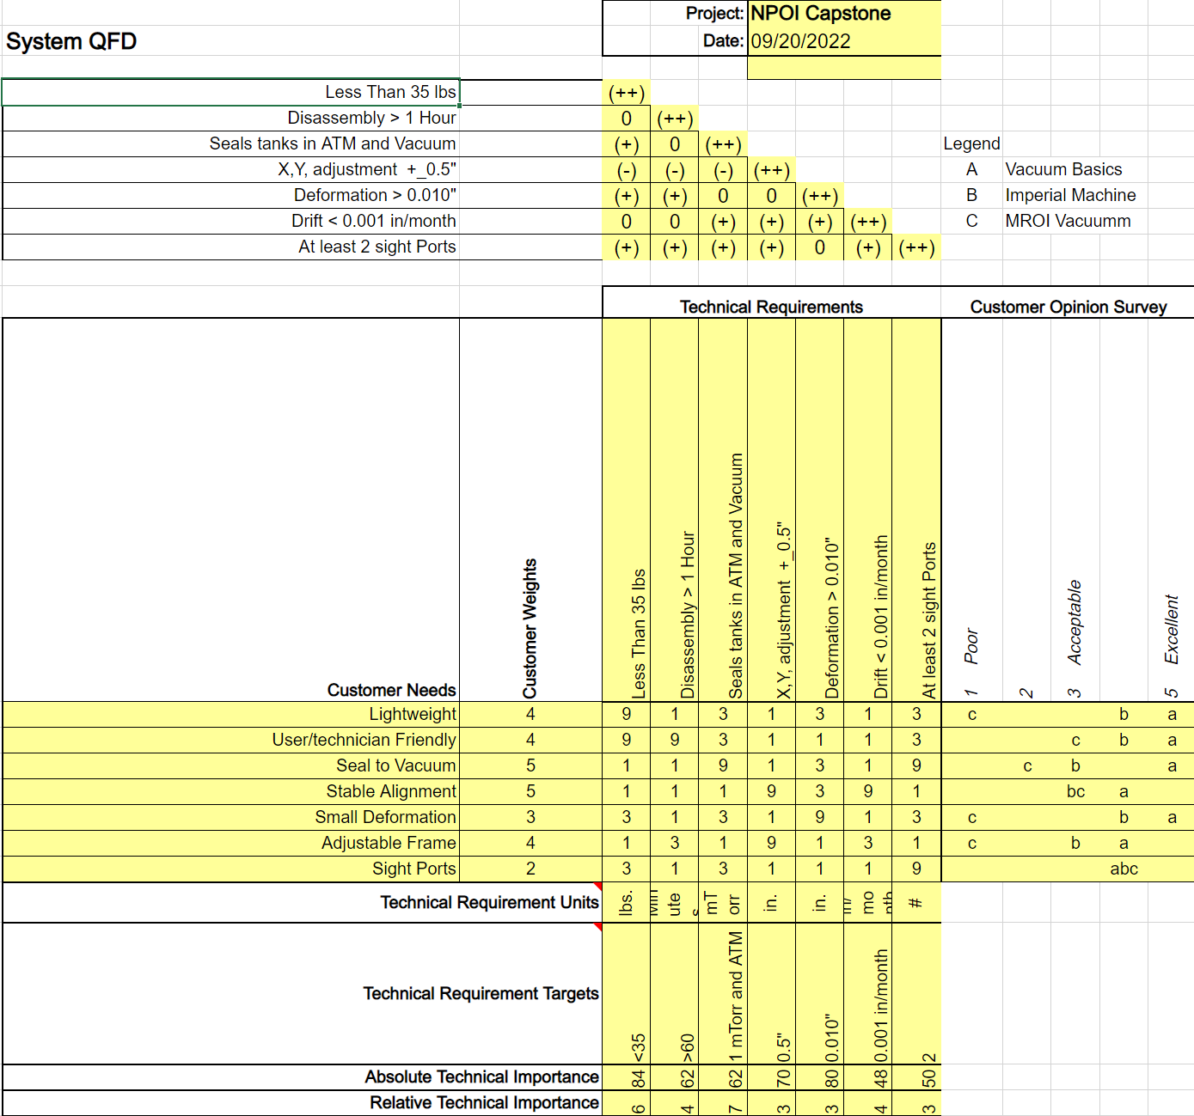
Fig. 2 - House of Quality (HoQ)

DESIGN SPACE RESEARCH
[Use this chapter to describe alternative approaches to designing your new or re-engineered system. Sources for this information include existing product descriptions, catalogs, engineering textbooks, the engineering literature, and the internet. Another very important source for some projects, especially (but not exclusively) for process re-engineering projects, is benchmarking.]
[Put introduction to Ch. 3 here detailing what the chapter contains before leading into Section 3.1.]

This chapter included the literature review which consists of five or more useful sources per student and how the sources would benefit the team during the project. Also, the team provided benchmarking for the main system and subsystem. For this project, the team was modifying an existing system that would satisfy the customers’ needs. Due to the project’s specific requirements, the literature review of each student may include the material company or manufacturing company that would help the team to achieve the goal of creating the actual objects, which included snoots, front and back seal plates. In the literature review, each student would have a particular part of the project to cover and find alternative solutions for the existing snoots, front and back seal plates. While in benchmarking section, each student would be in charge of one system and one subsystem that was covered in the literature review.

Literature Review
[Use this section to describe what sources were used for benchmarking and design research. This could have been done by examining similar systems, literature review, or web searches. Each student should have at least five relevant sources (academic and professional journals, books, websites, catalogs, interviews with sponsor, advisor, design tools etc.), given in the following subsections. For each source, include a summary and discuss how it specifically applies to your project design space.

Student 1 (Bradley Ian Kingsley)
This student would be in charge of finding alternative ways to reduce the lightweight of the existing seal plates. At the moment, the seal plates at NPOI weighed over a hundred pounds, which made the assembly/disassembly processes difficult as a gantry crane was required in order to support the processes. Due to that problem, the goal was to reduce the weight of the seal plates down to thirty-five pounds or less so that one person could assemble/disassemble the seal plates out of FDL tank without any need of gantry crane.
Light Weight Design Without Compromising Design for Manufacturing [16]
This source provided different methods to light weight the design, using different materials or changing the moment of inertia of the design to reduce weight. Because the seal plates and snoots had a fixed dimension, the team could only make changes based on the existing objects. By calculating where most of the stress applied to the seal plates, the team would change the design by removing the unnecessary parts with pattern on the seal plates to reduce its total weight.
How to Evaluate Materials – Properties to Consider [17]
There were many factors to consider when choosing the materials, not only the weight. From the article, there were about fourteen sections that could affect the outcome of the materials. For this project specifically, the team would focus on density, ductility and hardness than other properties. The density would directly affect the weight of the materials used while the hardness of the materials showed the deformation resistance when operating under vacuum conditions.
Material and Process Design for Lightweight Structures [18]
The book provided reports from the author about the method of reducing the damage in the bending methodology. Processing advanced steels could reduce the weight of the material and the bending effect. There were various methods that been used in the book to achieve the goal of reducing the weight of the material and structure, which would benefit the team for our project.
Aluminum supplier [12]
The existing seal plates were made of aluminum. Based on that experience, the team decided to use aluminum as the material for new seal plates. This aluminum supplier provided aluminum objects with different shapes and even customized extrusion which was that the team was looking for. The company’s aluminum process service could be useful when the team made the final product for the Spring term.
Interview with the client, Jim Clark
Jim Clark discussed with the team the main problems and difficulties when using the gantry crane during working hours. Jim Clark also suggested that the team could use magnesium for the seal plates due to its low density compared to aluminum, however, after careful consideration, the team decided not to use magnesium due to the cost and flammability.

Student 2 (Dustin John Haines)
This student would be in charge of sight ports and alignment of the whole system. The sight ports were asked by Jim Clark to check out everything during operating procedure. This student also studied the dimensions of the existing designs through the CAD drawings at NPOI.
Vacuum Viewport [23]
This website provided different types of sight ports, which also included the strength and spectrality. Based on the conditions of stellar and metrology beams, the team could choose the right sight ports to install in the seal plates.
Interview with Jim Clark
After a meeting with Jim Clark about the place of sight ports, the team learnt the particulars place to install the sight ports. Moreover, the team would customize the pattern on the seal plates to match with the client wants, the mushroom pattern.
NPOI CAD drawings
At NPOI, the team got in touch with the previous CAD drawings. By achieving the actual CAD drawings, this student could experiment with the best place to install the sight ports when under atmospheric pressure.
Sight Glasses [27]
This company provided various sight ports glasses and windows. The team could use this site as a reference when ordering a sight port to install on the seal plates.
Sealing options for vacuum chamber [20]
Although this source was about sealing options for vacuum chamber, the company themselves showed a great product which included a large amount of sight ports on the vacuum chamber. The team could contact the company when needed to do a custom sight port on the vacuum seal plates.

Student 3 (Trung Son Nguyen)
This student oversaw the connection and the flexibility for the snoot. Based on the team’ designs, each part of the snoot could be connected by several types of connectors. In this literature review, the student would cover distinct types of connectors as well as how to make the snoot more flexible.
Flexible Pipe Bellow [24]
This website contained diverse types of connections, from quick clamps, flange to pipe bellows. This company had great experience in making and supplying various connection parts as well as connection types. The team could use this information as a reference when doing the design for the snoot.
Metal bellows [25]
The bellows was a great connection due to flexibility. The website explained the function of the bellows as a flexibility component that could prevent leak as well as seal effectively. The metal bellows would be a great choice for the design of the snoot.
Interview with Jim Clark
Jim Clark had some specific requirements for the snoots. Firstly, the number of the snoots would increase from two to four for both way in and out of the stellar and metrology beams light. Secondly, the snoots would be easily removed for maintenance without showing displacement of the stellar and metrology beams light. With that information, the student decided that the snoots would be divided into four parts, with two parts connected to the inner room and front seal plates, one part would be removed independently, and the final part was the bellows.
The Importance of Choosing the Correct Material for Vacuum O-Rings and Vacuum Seals [1]
This source presented information about the benefit of choosing the right materials for the O-rings and vacuum seals. The deformation rates of varied materials could affect the quality of sealing, hence affecting the entire system. By knowing the
Fitting and Flanges [7]
The Ideal Vacuum company sold a variety of equipment and products for vacuum products. This included different types of fittings and flanges, which used to hold our snoot parts together. This company could be used to supply our required fitting parts.

Benchmarking
The benchmarking process would be used to display existing designs, which would be references for the team’s design. The benchmarking process consisted of the whole system level and subsystem level, which specified different aspects of the design. By doing the benchmarking process, the team could evaluate the relevant of existing design compared with the design the team wanted to make. With the help of benchmarks, the team would boost the design process through valuable references.

System Level Benchmarking
Existing Design #1: NPOI FDL vacuum tank

The existing design of snoots, front and back seal plates came directly from NPOI. Because the design would be based on the NPOI version, the team would take the design as main source to work on. The designs had all necessary dimensions on the seal plates to reduce the weight.
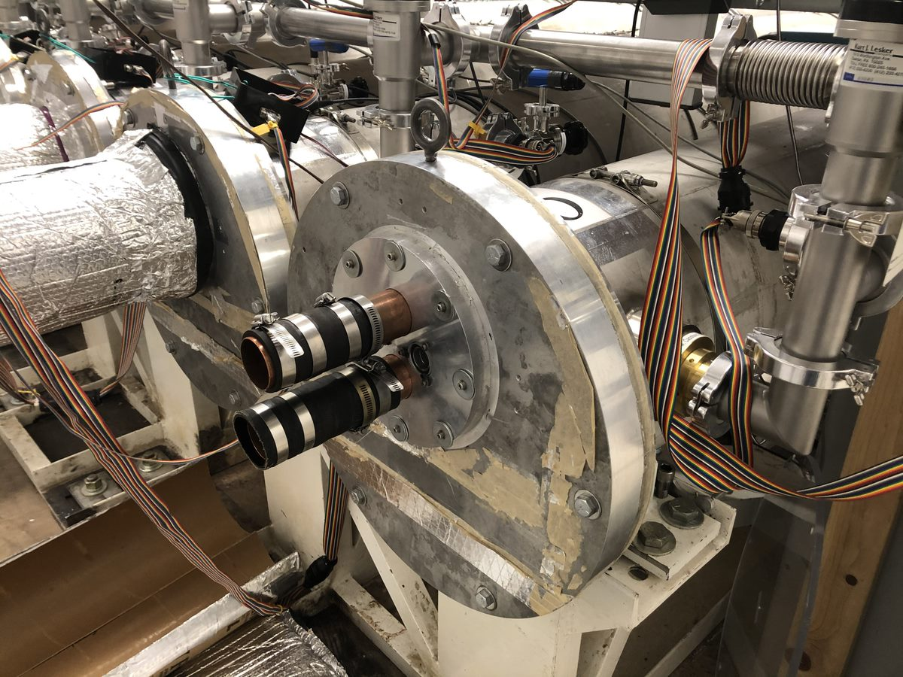
Fig. 3 - Front seal plate
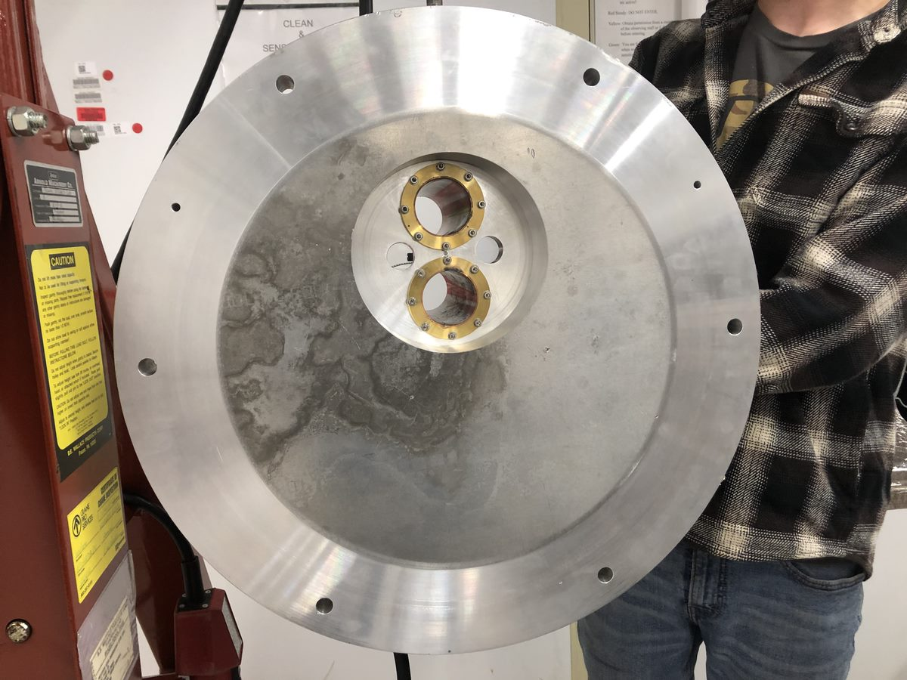
Fig. 4 - Back view of front seal plates.

Existing Design #2: Aluminum Vacuum Chamber
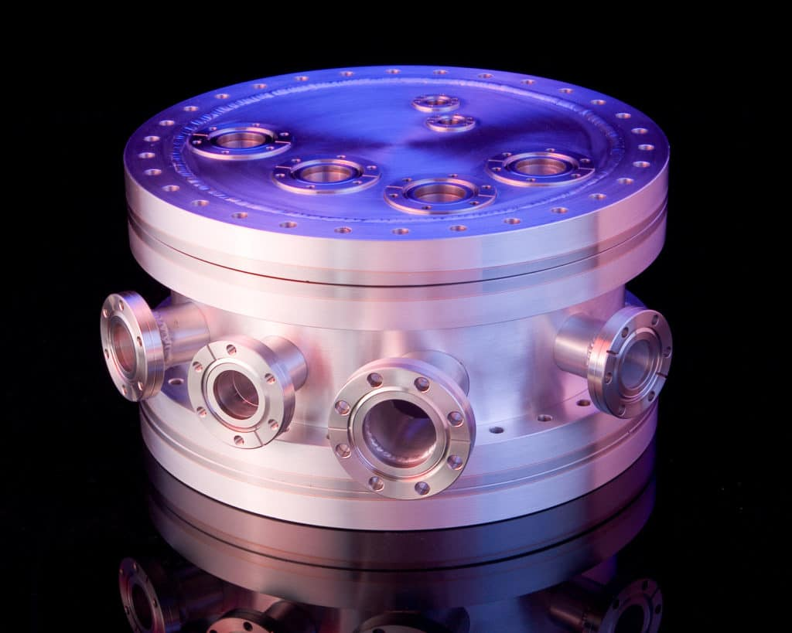
Fig. 5 - Aluminum vacuum chamber
This design was a vacuum chamber with various sigh ports to view inside during the process. Jim Clark, the client, wanted the team to add sigh ports on both front and back seal plates to observe the process and make sure that everything operated correctly. This design would help the team to learn and design the sight port that could withstand the vacuum force and had minimum deformation.[20]

Existing Design #3: Sealing aluminum chamber
This design showed similarity to the shape of the actual design, but smaller in scale. The seal of this vacuum chamber was thinner compared to the actual design but still could seal the chamber tank with the support of three clamps. The team could use the design to lightweight the seal plates by reducing the thickness of seal plate and adding clamps to tight the seal plates with the tank [21].
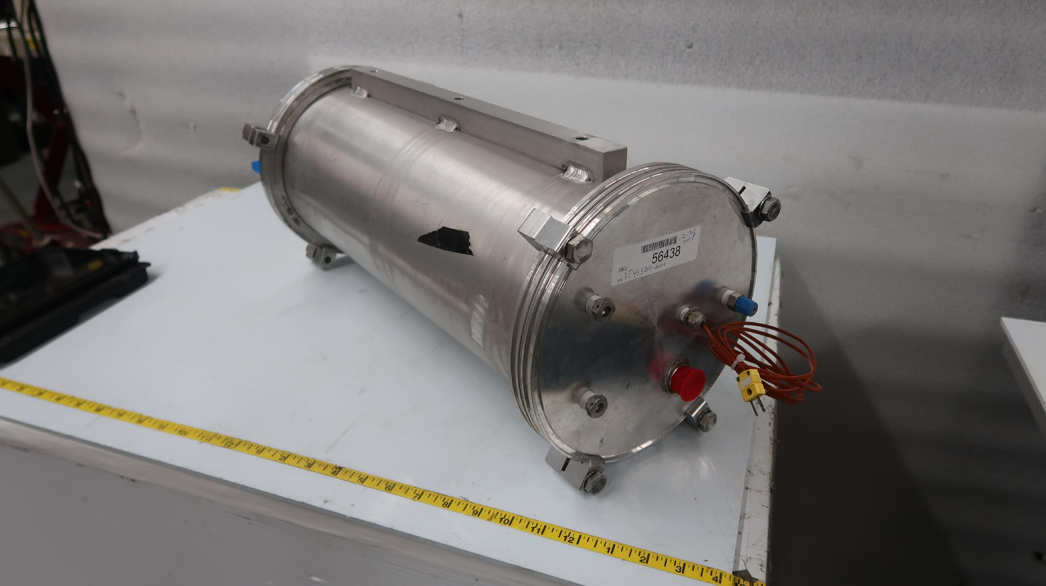
Fig. 6 - Sealing Aluminum Chamber

Subsystem Level Benchmarking
[Use this section to discuss existing designs that address requirements relevant to your project at the subsystem level. Under each subsystem heading, list existing designs meeting similar or related requirements. There must be at least three existing designs described under each component/subsystem.]

Subsystem #1: Seal Plates
The seal plates had an important role in this project. From the functional decomposition model, the seal plates had a series of requirements, which included to be lightweight, being able to withstand vacuum force and having a small deflection rate. The seal plates could directly affect the lab result if they did not function as intended so the seal plates were one of the main focuses on this project.

Existing Design #1: Descriptive Title
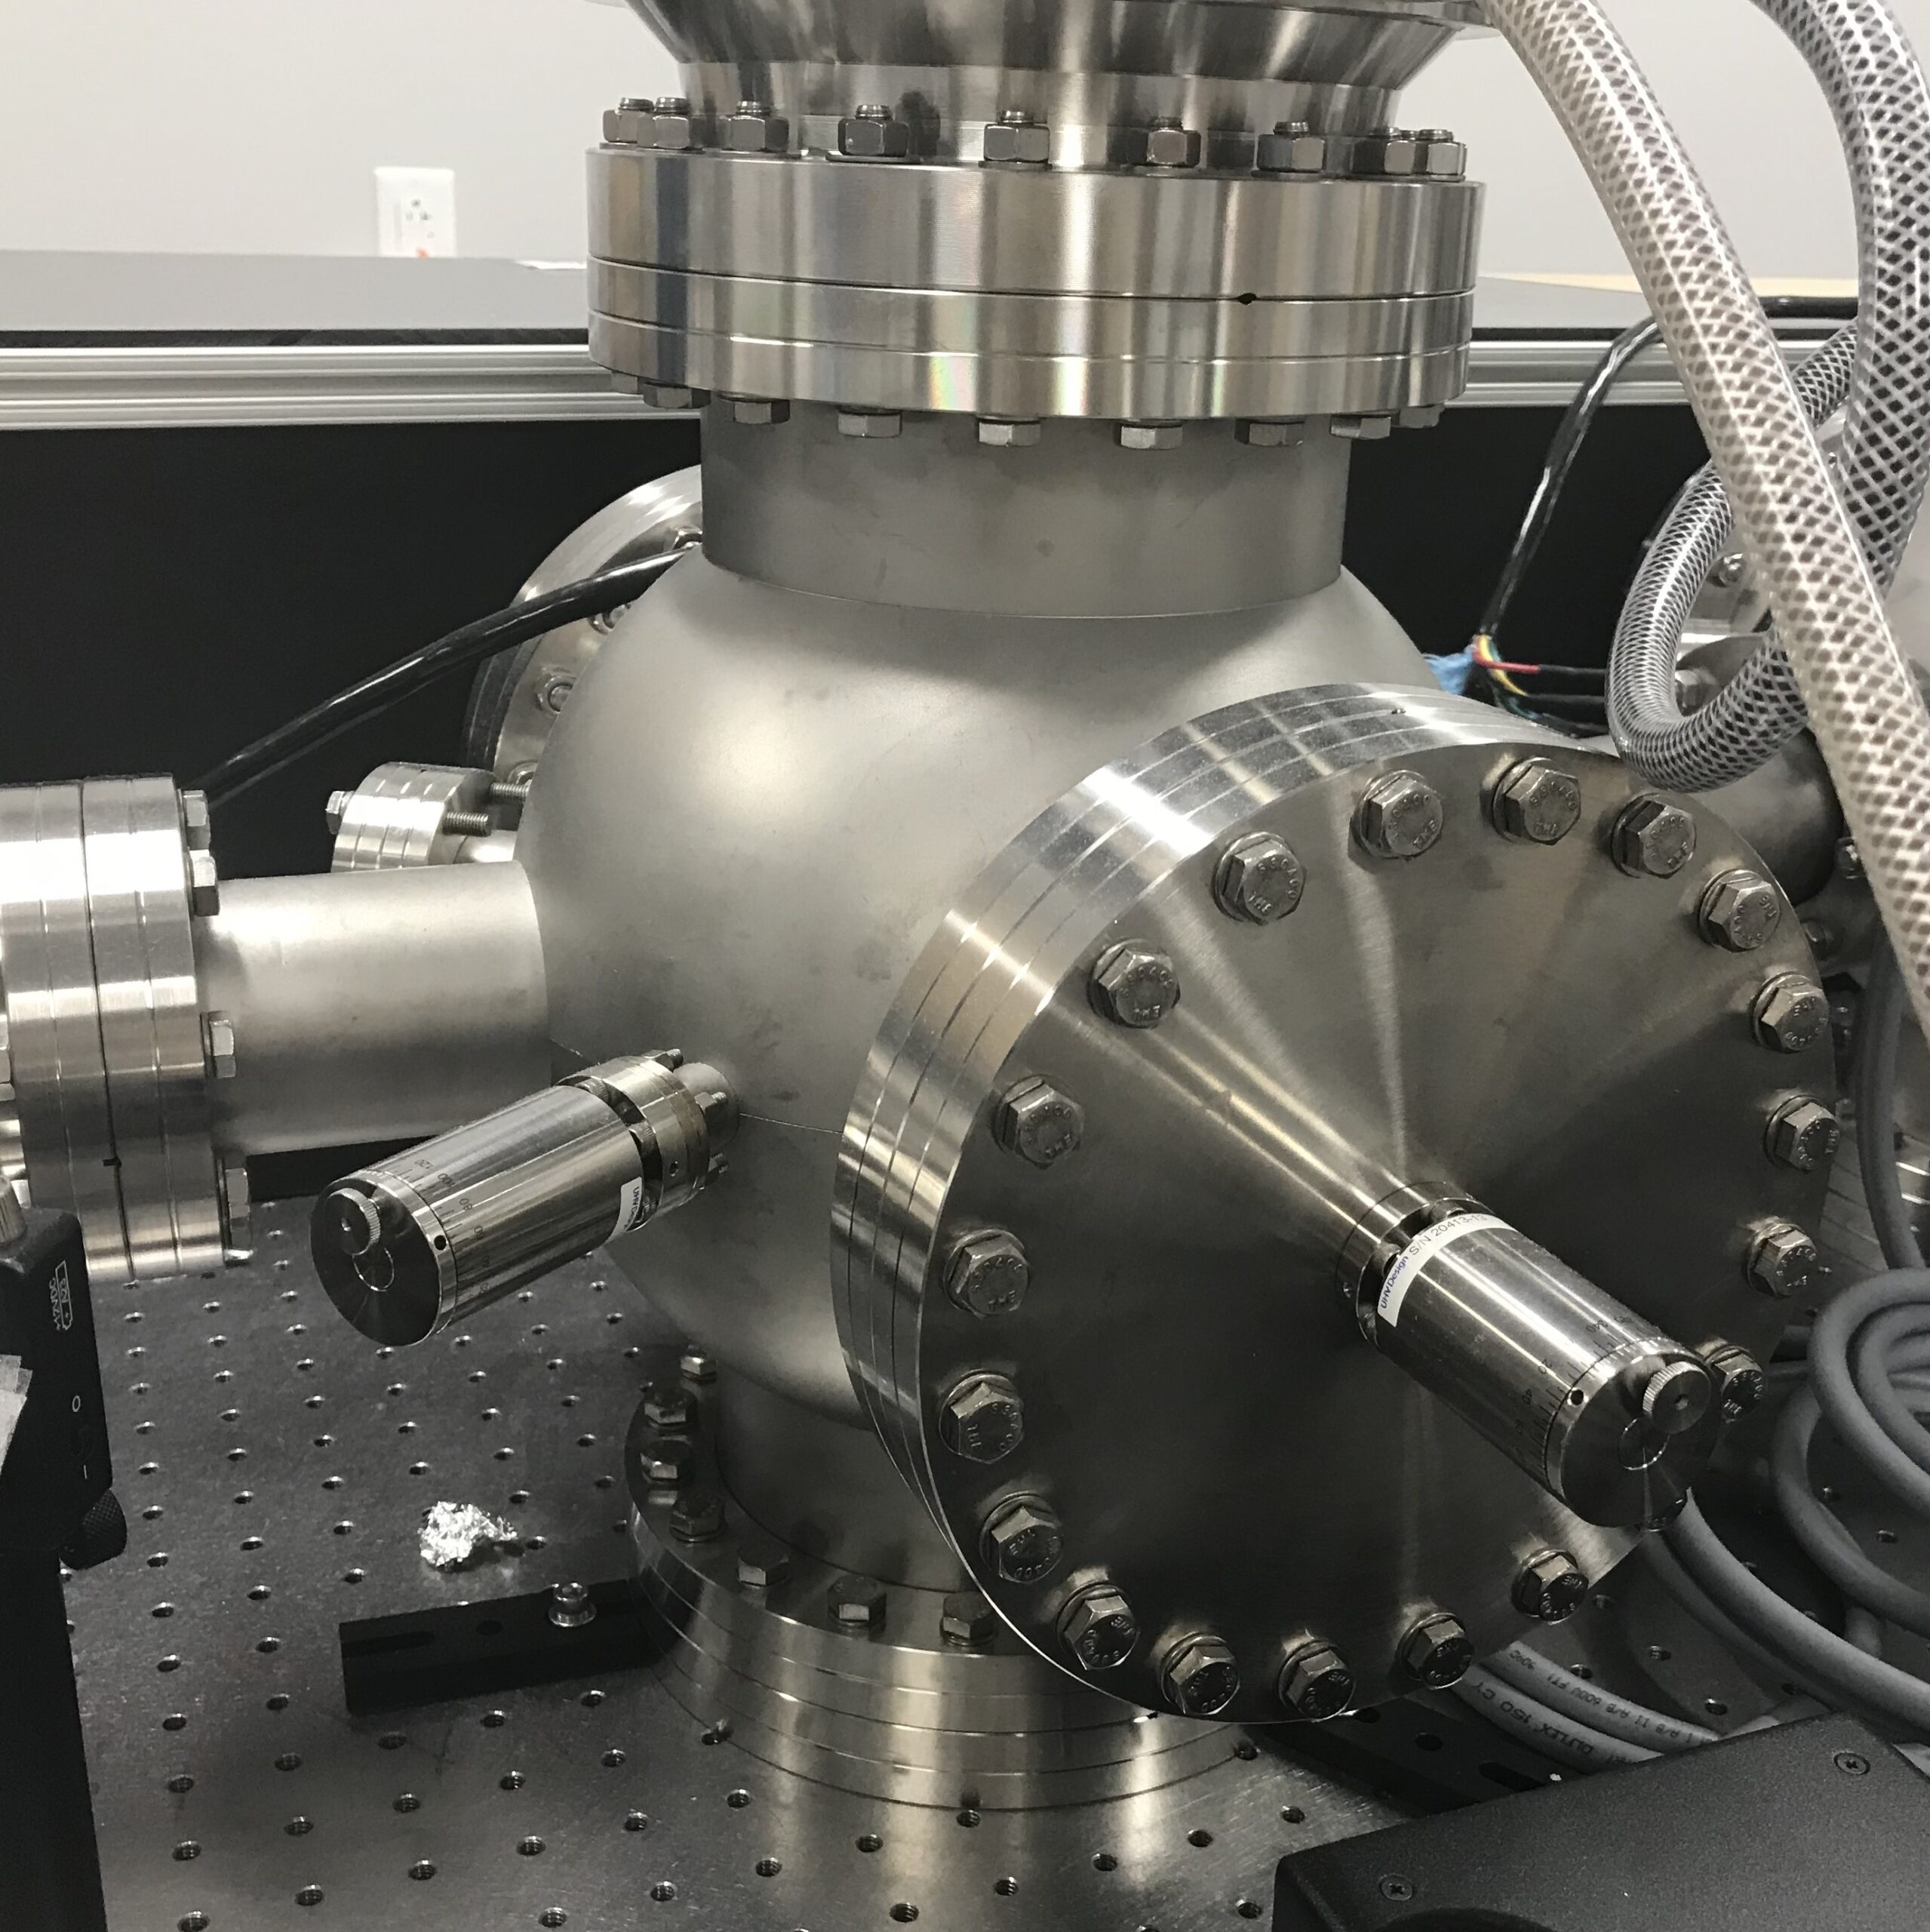
Fig. 7 - High levels of vacuum tank
The seal plates showed excellent tightness and reduced the deformation rate, however, as the team wanted a lightweight seal plate, this design was for reference only [22].

Existing Design #2: Demountable Seals: Metal
The metal seals were used in high vacuum levels. Common metal seals include the knife-edge, wire seal and metal jacketed spring seals. Metal jacketed spring seals consist of a helical spring enclosed within a ductile outer metal jacket which yields under compression to create a seal [26]. This seal was a reference for the team to use in the project.

Existing Design #3: Demountable Seals: Elastomers
The common seal used on vacuum chambers was a flanged or door joint sealed with an elastomer gasket. This type of seal also included an O-ring that would compress and fit inside the vacuum chamber, which would seal the tank perfectly [26]. This design suggested the team of a seal plate that used O-ring.

Subsystem #2: Sight Port
From the functional decomposition model, the seal plates needed window see through for the stellar and metrology beams light to go through. This subsystem investigated various existing sight ports to install on the seal plates. This subsystem was important because the stellar and metrology beams light was the main purpose of the FDL tank, so the sigh port needed to be clear and able to work under vacuum conditions.

Existing Design #1: Caf2 Vacuum Viewpoint
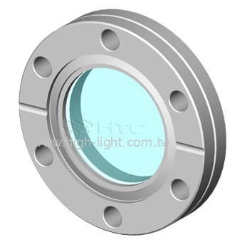
Fig. 8 - Caf2 Vacuum Viewpoint
The Caf2 lenses had high transmission from 250nm to 7μm. This window manufactured from vacuum UV grade calcium fluoride could be used in our project [23].

Existing Design #2: Sapphire Viewpoint
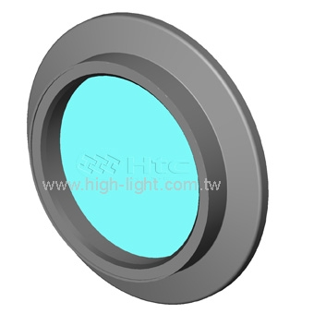
Fig. 9 - Sapphire Viewpoint
The sapphire viewport provided excellent optical quality, with the transmission of UV up to eighty percent. This viewport could be used under pressure of 10^(-8) Torr with temperature range from -100ºC to 450ºC. The team could use this sight port for the project [23].

Existing Design #3: KF Flange Tempered Glass Viewpoint
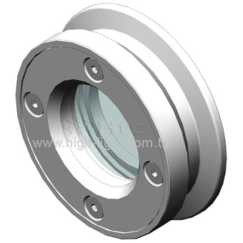
Fig. 10 - KF Flange Glass Viewpoint
This KF Flange Glass sigh port included an O-ring to have tight seal with the plate surface. This sigh port had high vacuum applications. The team could use this sigh port for the stellar and metrology beams [23].

Subsystem #3: Snoots and Snoot Fixture/Adjuster
This subsystem was important because the snoots delivered stellar and metrology beams. From the black box model, the stellar and metrology beams went inside the vacuum tank through one snoot and came back in another snoot. That was why by focusing and snoot and snoot adjuster, the team would reduce the time required for snoot maintained as well as reduce the error of stellar and metrology beams displaced from the wanted place.

Existing Design #1: Horse Sleeve Seal
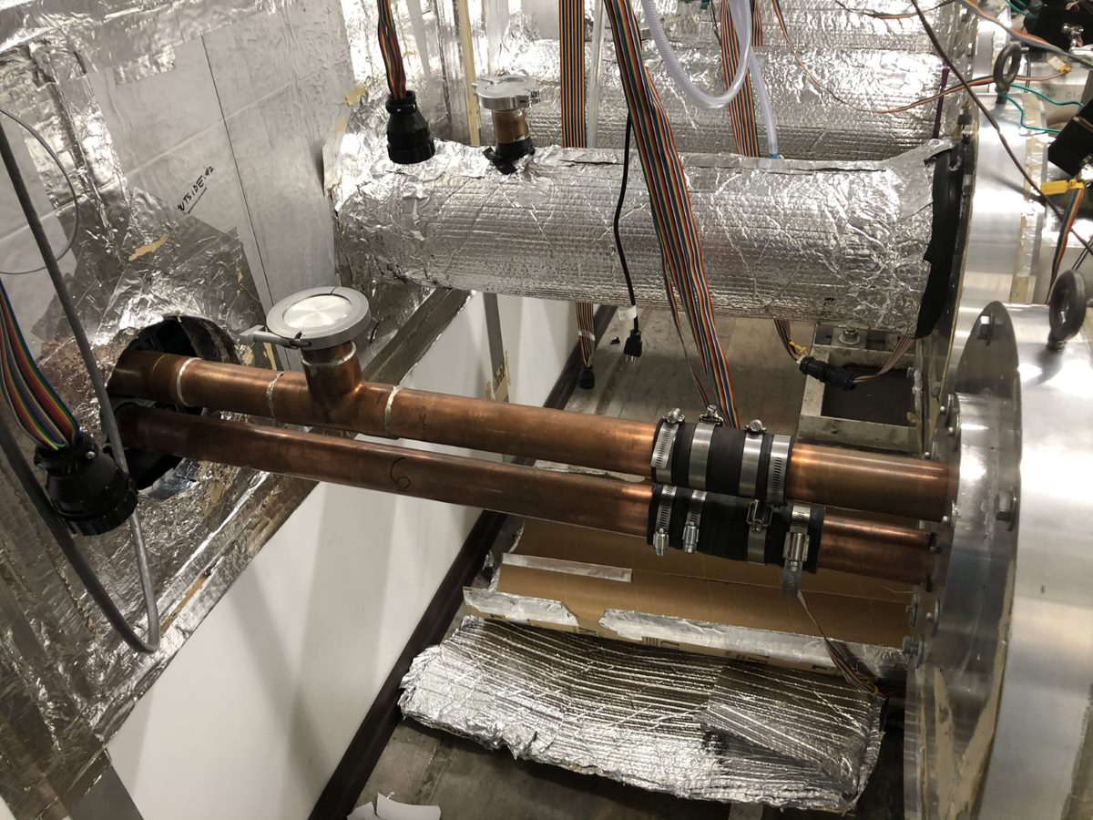
Fig. 11 - Exposed Snoot
This existing subsystem contained a part of the snoot connected to the seal plate and another part went inside the dark room. The two parts were connected by a horse sleeve seal. This design provided an additional method that the team could use to connect different parts of the snoot together.

Existing Design #2: Clamp connection
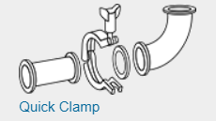
Fig. 12 - Clamp connection
This design was about having two parts of the snoot connected by an O-ring and sealed with a quick clamp. This design inspired our team to use this as final snoot connection due to the low price of the clamp and the ability to seal the air and light. [24]

Existing Design #3: Metal Bellows
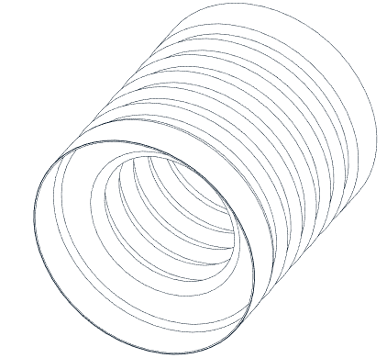
Fig. 13 - Metal Bellows
Metal bellows provided flexibility to the snoot. By using the bellows, the team could have the snoot in the dark room fixed and connected to the metal bellows while the outside snoot could easily connect to the dark room snoot through the metal bellows. With the flexibility from the metal bellows, the team did not need to remove the dark room snoot. [25]

Functional Decomposition

Black Box Model
A black box model is a simple diagram which shows how a system has specific input and output, but does not show the inner workings of how this system will work. Specifically what signal, energy, and material will be input and output from the system. Figure #: Black Box Model, shows the model for the P5 NPOI Capstone.
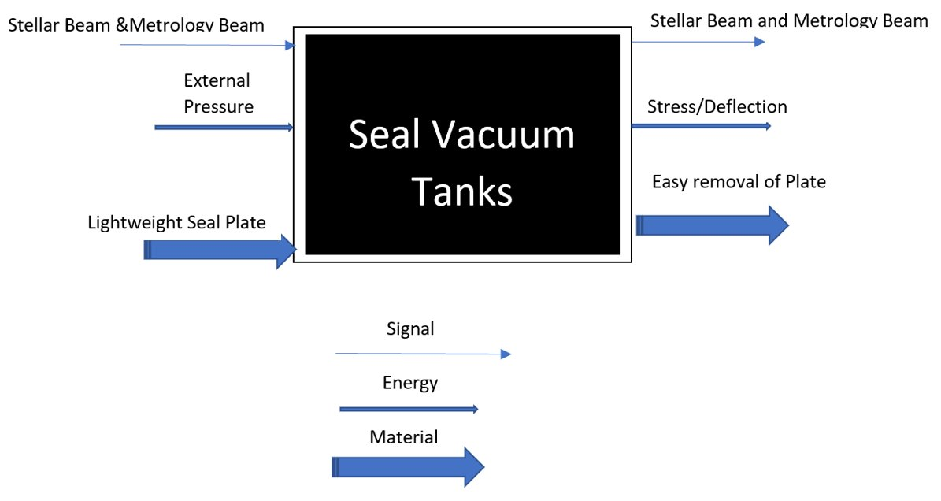
Fig. 13 - Black Box Model
The inputs for the system are defined as stellar/metrology beams, external pressure, and lightweight seal plate. The beams being input are the beams which must pass through the seal plate, through a vacuum window, allowing the light to be reflected at the FDL cart. External pressure is also the input because external pressure will put force on the seal plate, specifically strain energy. The seal plate being lightweight is also an input, this is because the plate must be light to be able to be installed by hand. The signal output is the metrology/stellar beams, these beams act as the signal for the system because without these there would be no interferometry. The output of energy is stress and deflection of the seal plate, the input pressure has a direct cause for stress and deflection. The output for material is the seal plate must be easy to remove, allowing the material to be moved easily.
This black box model allows the team to simplify the system to only needed components and shows the team how the system works. This model shows all the absolutely needed components in the system, specifically the seal plate with windows allowing signal through and how the seal plate reacts with nature and humans. This model also shows the team how the system works in a very general sense, Allowing for concepts to be generated that easily incorporate the needed inputs and outputs, ensuring the needed features for functionality are included in each design.

Functional Model/Work-Process Diagram/Hierarchical Task Analysis
The functional model is used to show the specific functions of a specified part or design. Specifically creating a flow diagram of how the part will work with more specifics, that are nt shown in the black box model. The team created a functional model of the front seal plate to analyze, being what functions does the seal plate have and what is specifically needed for the design. The front seal plate function model is presented in figure #.
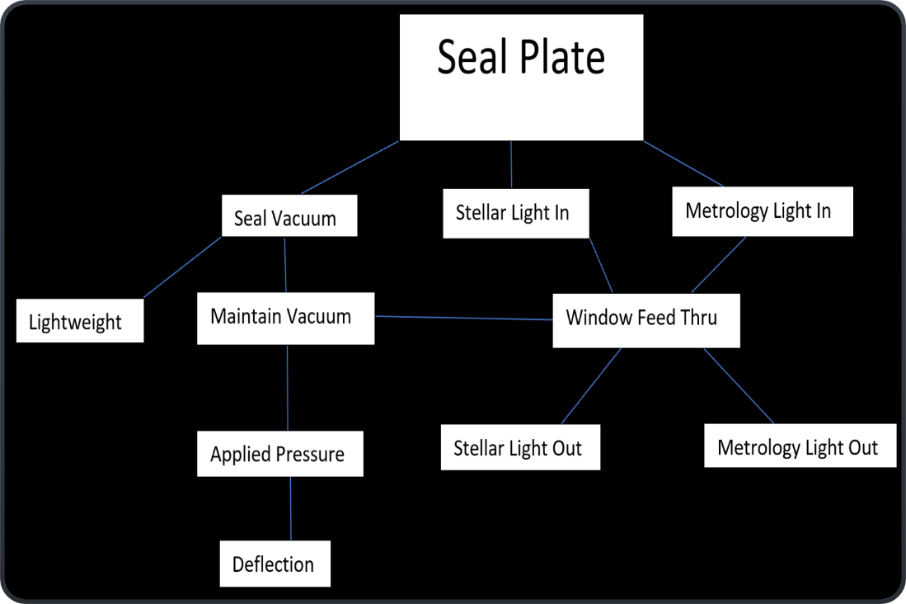
Fig. 14 - Function Decomposition Model
The functional model shown for the front seal plat shows 3 main functions with a few sub functions that are essential for success of the design. The seal plate will allow stellar and metrology light in and out, using vacuum windows for each input or output beam. This specifies the plate must have transparent windows sealed to the plate which can allow laser and stellar light to pass in and out of the FDL tank. The need for the plate to seal to vacuum is essential to success of the design, this is tied with lightweight and maintains vacuum. Although the seal plate will be lightweight (>35 lbs.), it must maintain a vacuum without issue, even if most of the plate weight is removed strategically for weight reduction. The applied pressure and deflection also correlated with maintaining a vacuum, when the seal plate gets deformed by pressure, the specified O-ring geometry might change. This shows the need for advanced finite element analysis (FEA) to ensure the seals do not leak when the plate deforms. The decomposition models give the group a simple chart to follow to ensure all the needed geometry and pass through will be included and will work properly, even with changes from TAM to vacuum.

CONCEPT GENERATION
The following section includes all the full-system as well as the subsystem concepts. Some figures are included at the end of the section to clarify some of the designs.

Full System Concepts
The full system concepts primarily vary in three categories: material, seal type, and sight port material. The overall design, such as thickness, mounting type, sight port location, etc. are heavily restricted by the customer, therefore there is not much visual difference between each concept.

Full System Design #1: Magnesium, Rubber Sleeve Seal, Acrylic Sight Port. (M.R.A.)
The M.R.A. design uses magnesium as the material for the seal plates, with a rubber sleeve seal and acrylic sight ports. The magnesium allows the team to easily achieve the weight constraint, although magnesium is flammable, making the machining of that material more difficult. The rubber sleeve seal provides a cheap and easily implemented way to keep a seal in the vacuum, but slightly less reliable than some of the other alternatives. Finally, acrylic is cheaper and allows clear viewing into the FDL’s but is prone to cracking and is weak.

Full System Design #2: Aluminum, O-Ring Seal, Polycarbonate Sight Port. (A.O.P.)
The A.O.P. design uses aluminum as the material for the seal platers, along with an O-ring seal, and polycarbonate sight ports. Aluminum is a cheap material that is easily machines, however it is weaker. The O-ring seal type is currently implanted with the existing seal plates making it easier to implement. The polycarbonate sight ports are lighter and stronger than the other alternatives, but do not offer as clear of a view.

Full System Design #3: Steel, Hose Sleeve Seal, Tempered Glass. (S.H.T.)
The S.H.T. design uses steel as the material for the seal plates, alongside a hose sleeve seal, and tempered glass sight ports. Steel is the strongest material considered, but is extremely heavy, meaning that substantial material would have to be cut out of the plate to reach our weight goal. The hose sleeve seal is like the rubber sleeve, but is slightly cheaper and more easily ordered, while being slightly weaker than the rubber sleeve. The tempered glass is extremely clear but is much more expensive than the other alternatives and heavy.
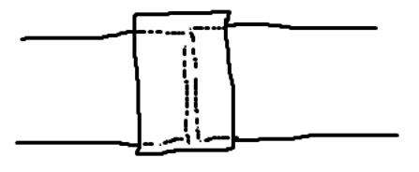
Fig. 15 – Hose Sleeve Seal

Subsystem Concepts
The overall design includes three subsystems; front seal plate, rear seal plate, and snoot/snoot adjustment configuration.

Subsystem #1: Front Seal Plate

1.1.1.1 Design #1: Preexisting Plate
This seal plate uses the preexisting snoot mount that the current seal plates use. The only difference between the old plates and this design are the material, and some light weighting. Using this Plate makes implementing our design much easier, but also restricts some of the functions that we need to design for.

1.1.1.2 Design #2: Custom Mount
This design will use a custom snoot mount that attaches to the front seal plate. This means that more will have to be spent to machine the new mount but will allow for new housing for the snoots. The new mounts will also be lighter.

Subsystem #2: Sight Port

Design #1: 3 Sight Port
This design uses three sight ports aligned along the top of the seal plate. This will allow for more visibility on the inside of the FDL, depending on the area of interest. Cutting more holes into the plate will make it lighter, but also weaker.
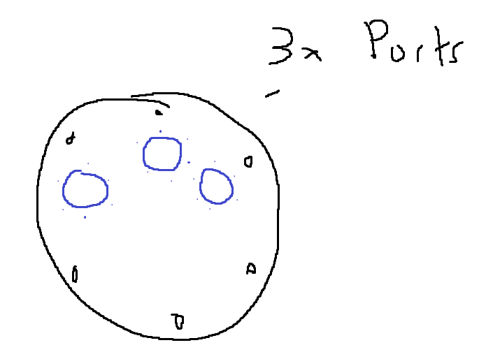
Fig. 16 - 3 Sight Port Configuration

Design #2: 2 Sight Port
This design, like the previous design, will have two sight ports located along the top of the seal plate. This is the bare minimum number of separated seal plates to allow for a light to be shone into the vacuum, along with a port for viewing. The decreased number of ports allows the plate to be stronger, but slightly heavier.
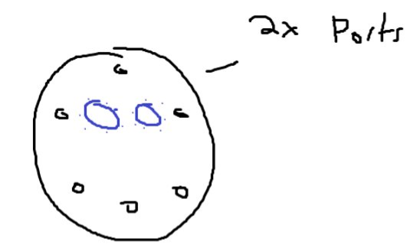
Fig. 17 - 2 Sight Port Configuration

Design #3: Window Sight Port
This design uses a singular, large sight port that curves around the plate. This option allows for the most visibility, but is extremely weak, and prone to deformation. This would jeopardize the strength of the seal plate.
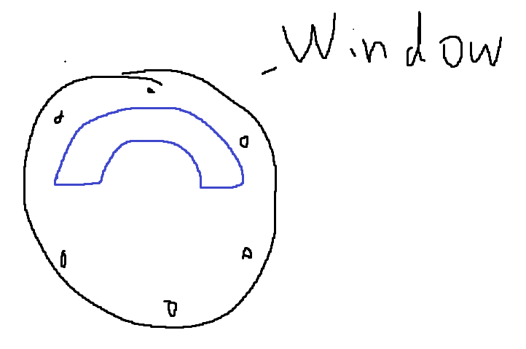
Fig. 18 - Window Sight Port Configuration

Subsystem #3: Snoots and Snoot Fixture/Adjuster

Design #1: Screw Adjuster
This design uses a screw mounted to a baseplate to move the snoots for alignment. This will be done by having the snoots covered in a metal housing connected to a screw on the bottom and side of the snoot. This design is cheap and easy to manufacture, but is not precise and not stable.
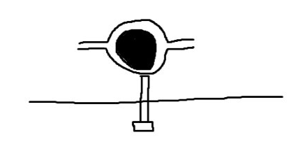
Fig. 18 - Screw Adjuster

Design #2: Hose-Like-Endings
This design uses a hose-like-material that is malleable that will be connected to a baseplate and the snoot. This will allow the snoot to move in every direction with little effort. While this design is cheap and easy to remove when maintenance is being performed, it is very weak.

Design #3: Spring Adjuster
This design uses a spring to mount the snoot. This is done by suspending the snoot via a spring connected to surrounding housing for the snoot that will be able to be fastened to varying heights and angles, along the side of the baseplate. This design will be easy to adjust, and will be strong, but is limited in the ranges of adjustment
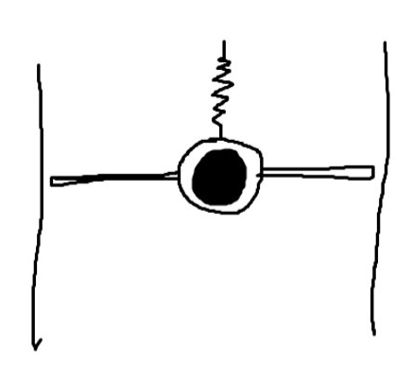
Fig. 19 - Spring Adjuster

Design #4: 4-Section Snoot
The 4-section snoot includes a snoot fixed to the wall, a bellow, the intermediate pipe, and the snoot attached to the front plate. The bellow is the flexible aspects of the design, allowing some movement in the snoot. This configuration allows for increased customization. The increased number of pieces in the assembly makes it less stable, however. The amount of seals and clamps increases as well, making the overall cost increase.
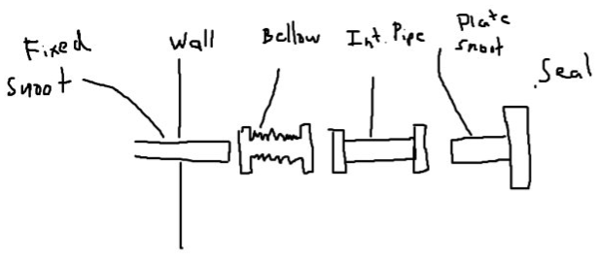
Fig. 20 - 4-Section Snoot Configuration

Design #5: 3-Section Snoot
The 3-section snoot is similar to the previous design, but it combines the fixed snoot in the wall with the bellow. This prevents some alterations during maintenance but will make the assembly more stable.
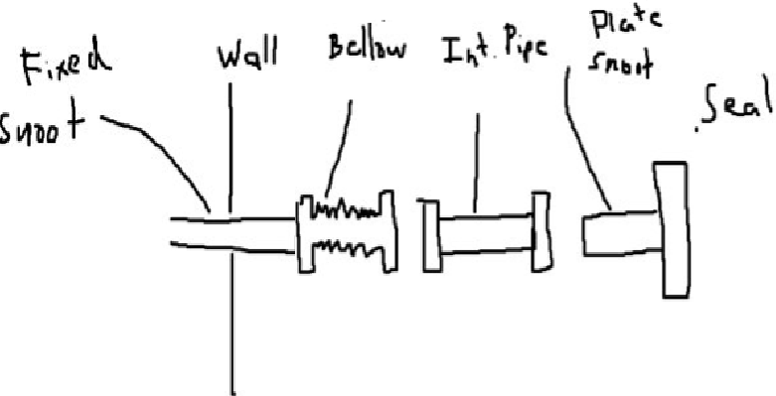
Fig. 21 - 3-Section Snoot Configuration

DESIGNS SELECTED – First Semester
Section 5 represents the final decisions made after generating the initial designs. The designs are compared to one another as well as the customer needs and engineering requirements. Both the good and bad aspects of each design are analyzed and are rated based off those criteria. Included in this section is the Pugh and Decision Matrix for our projects design.

Technical Selection Criteria
While evaluating the previous designs, there were critical technical criteria that were used to evaluate each concept, which closely relate to the customer needs/engineering requirements. There exist two separate modes of evaluation, one for the seal plates, and one for the snoot/snoot mounts. For the seal plates, weight, price, strength, machinability, and visibility were the criteria. For the snoots, price, strength, and reliability were considered. Each aspect was directly compared to each other via a Pugh Chart to achieve a baseline evaluation. Each aspect of the design was evaluated (i.e., plate material, sight port material, etc.) and then the total values were summed up to achieve an overall score for each design. After further consideration, the same criteria were used in a decision matrix, in this case each element was given a weight, based on importance for the overall design.

Rationale for Design Selection
After using the methods previously described to evaluate designs, two stood out as the best plate designs; A.O.P. and M.R.A. All three full system concepts were first evaluated in the following Pugh Chart,

TABLE I - Pugh Chart for Full System Concepts.
 | Option 1 | Option 2 | Option 3
Criteria | M.R.A. | A.O.P. | S.H.T.
Weight | +++ | + | --
Price | - | + | -
Strength | + | ++ | +++
Machinability | -- | ++ | 0
Visibility | + | + | ++
Total: | +2 | +7 | +2

After some elaboration, it was decided that the first two options would progress to the next stage of evaluation. Even though options 1 and 2 got the same score, the last option is not feasible for this project. The steel is much too heavy, and the tempered glass is not as strong or reliable as we want. The other designs are more likely to work. They will be further evaluated with criteria weights with a decision matrix. The snoot/snoot configurations will only be evaluated using a decision matrix as there are already few options. The following table shows the Decision Matrix for the 2 remaining full-system concepts;

TABLE II - Decision Matrix for Full System Concepts.
 |  | Option 1 | Option 2
Criteria | Value Weight | M.R.A. | A.O.P.
Weight | 3 | +++ | +
Price | 2 | - | +
Strength | 3 | + | ++
Machinability | 1 | -- | ++
Visibility | 1 | + | +
 | Total: | +8 | +14

Weight and strength are the most valuable traits as specified by the client. Price is secondary, but still important as we have a strict budget. Machinability refers to how easy it would be for the team to machine the parts or how cheap it would be if it is outsourced. Visibility is how well the sight ports would let an operator see into the FDL. These were given the least weight because each of the issues of machining these parts are simple, and each of the chosen materials are clear, so regardless of the quality one will be able to see through the material. Each evaluation is simple. Magnesium is extremely light and expensive while aluminum is not as light but much cheaper. Both materials can handle the load, this can be shown through some SolidWorks evaluation of the models we have made already. Magnesium is flammable, making the machining of the part more intensive, while aluminum is easy to machine. Both acrylic and polycarbonate are see-through. The following table shows the decision matrix for the snoot designs.
TABLE III - Decision Matrix for Snoot Alignment.
 |  | Option 1 | Option 2 | Option 3
Criteria | Value Weight | Screw | Hose-like-endings | Spring
Price | 1 | ++ | + | ++
Strength | 3 | - | + | 0
Accuracy | 3 | - | ++ | +
 | Total: | -4 | +10 | +5

All options will be cheap, so it was weighed the lowest, while strength and accuracy were weighted much higher. Each design must be able to hold up the metal snoots and be able to accommodate small alterations for alignment. The screw option is extremely cheap, but inversely is not strong or accurate. The hose like ending is cheap, but also provide decent strength. They allow for extremely minor adjustments as well. The spring is also cheap but is lacking in strength as the spring must be weak enough to freely move. Accuracy also suffers as there can only be so many orientations available.

As concluded above, the A.O.P. and hose-like-endings designs scored the best, so they are the designs that we will be designing in the future.

REFERENCES
[1] 'The Importance of Choosing the Correct Material for Vacuum O-Rings and Vacuum Seals'. Apple Rubber. [OnlineAccess]. https://www.applerubber.com/hot-topics-for-engineers/the-importance-of-the-correct-material-for-vacuum-o-rings-and-vacuum-seals/​
[2] J.A. Clark III , J. Murphy, L. Ha, J. P. Walton , J. Howard, J. T. Armstrong, G. C. Gilbreath , R. B. Hindsley , and T. A. Pauls. 'Alignment of vacuum feed stations on the Navy Prototype Optical Interferometer'. [OnlineAccess]. https://apps.dtic.mil/sti/pdfs/ADA477246.pdf​
[3] 'Vacuum Chambers and Optical Equipment'. Imperial Machine & Tool CO. [OnlineAccess]. https://www.imperialmachine.com/vacuum-chambers​
[4] 'The long-stroke MROI vacuum delay lines from concept to generation' [OnlineAccess]. https://www.researchgate.net/publication/237371110_The_long-stroke_MROI_vacuum_delay_lines_from_concept_to_production​
[5] “Kurt J. Lesker Company,” www.lesker.com. https://www.lesker.com/index.cfm (accessed Oct. 11, 2022).​
[6] “Parker Engineering Your Success Motion Control Technology,” Parker Hannifin Corporation, 2020. https://www.parker.com/portal/site/PARKER/menuitem.b90576e27a4d71ae1bfcc510237ad1ca/?vgnextoid=c38888b5bd16e010VgnVCM1000000308a8c0RCRD&vgnextfmt=EN​
[7] “Fittings, Flanges, and Hardware | Ideal Vacuum,” www.idealvac.com. https://www.idealvac.com/Fittings-and-Flanges/ct/2 (accessed Oct. 11, 2022). ​
[8] “Vacuum Fittings and Flanges,” www.newport.com. https://www.newport.com/c/vacuum-flange-components (accessed Oct. 11, 2022).​
[9] “Optical Imaging | Laser Optics | Edmund Optics,” www.edmundoptics.com. https://www.edmundoptics.com/​
[10] “Carr,” McMaster. [Online]. Available: https://www.mcmaster.com/. [Accessed: 11-Oct-2022]. ​
[11] “Thorlabs, Inc. - your source for fiber optics, laser diodes, optical instrumentation and polarization measurement & control,” Thorlabs, Inc. - Your Source for Fiber Optics, Laser Diodes, Optical Instrumentation and Polarization Measurement & Control. [Online]. Available: https://www.thorlabs.com/. [Accessed: 11-Oct-2022]. ​
[12] “Aluminum supplier,” Aluminum Supplier | Bar, Sheet, Plate, Tube, Pipe, Shape. [Online]. Available: https://www.industrialmetalsupply.com/Products/Metals/aluminum?gclid=EAIaIQobChMIp7f_rKrZgIV9QetBh3t0QAOEAAYASAAEgKFvPD_BwE. [Accessed: 11-Oct-2022]. ​
[13] “Home,” Alaska Rubber Group. [Online]. Available: https://www.alaskarubbergroup.com/. [Accessed: 11-Oct-2022]. ​
[14] Www.htcvacuum.com 日揚科技股份有限公司 |, “Vacuum components suppliers: Vacuum products manufacturer: Vacuum Chamber Kits - HTC Vacuum,” Vacuum Components Suppliers| Vacuum Products Manufacturer | Vacuum Chamber kits - Htc vacuum. [Online]. Available: https://www.htcvacuum.com/en-global/vacuum-components?gclid=EAIaIQobChMIrKbp4arZ-gIV-BetBh3FDAJXEAAYASAAEgKxi_D_BwE. [Accessed: 11-Oct-2022]. ​
[15] “Socket Head Cap Screws Dimensions & Specs | AFT Fasteners,” www.aftfasteners.com. https://www.aftfasteners.com/socket-cap-screws-dimensions-and-mechanical-properties/ (accessed Oct. 11, 2022).
[16] Light Weight Design Without Compromising Design for Manufacturing. www.custiv.com/blog/systems-level-weight-reduction. Accessed 23 Oct. 2022.
[17] “How to Evaluate Materials – Properties to Consider.” MetalTek, 23 Aug. 2022, www.metaltek.com/blog/how-to-evaluate-materials-properties-to-consider.
[18] Al-Samman, Talal. Material and Process Design for Lightweight Structures. MDPI AG, 2019.
[19] “Aluminum Vacuum Chambers.” Atlas Technologies, 10 May 2021, www.atlasuhv.com/products/vacuum-chambers/aluminum-vacuum-chambers.
[20] “Sealing Options for Aluminum Vacuum Chambers.” Meyer Tool & Mfg., www.mtm-inc.com/sealing-options-for-aluminum-vacuum-chambers1.html. Accessed 23 Oct. 2022.
[21] “Sharon Vacuum Custom Chamber - Vacuum Systems.” BMI Surplus, 14 Sept. 2021, bmisurplus.com/product/sharon-vacuum-custom-chamber.
[22] Apex Vacuum. “Sharon Vacuum Chambers.” Apex Vacuum, 12 Aug. 2020, apexvacuum.com/sharon-vacuum-chambers.
[23] “Vacuum Viewports ” Htc Vacuum, www.htcvacuum.com/en-global/vacuum-components/vacuum-viewport/sapphire-viewport. Accessed 23 Oct. 2022.
[24] Flexible Pipe Bellows | McMaster-Carr. www.mcmaster.com/flexible-pipe-bellows. Accessed 23 Oct. 2022.
[25] Components, M. “Metal Bellows.” MW Components, 18 Aug. 2022, www.mwcomponents.com/metal-bellows.
[26] “---.” Meyer Tool & Mfg., www.mtm-inc.com/sealing-options-for-aluminum-vacuum-chambers1.html. Accessed 23 Oct. 2022.
[27] LJ Star Incorporated. “Sight Glasses, Windows, and View Ports | Find Your Perfect Model.” LJ Star, 19 Aug. 2022, www.ljstar.com/product-lines/sight-glasses.

